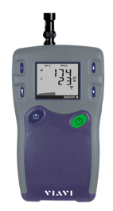
VIAVI Seeker X

Digital LeAKAGE Detector

The VIAVI Seeker X leakage detector provides the agility to monitor leakage anywhere in a channel lineup, with the sensitivity and speed to accurately detect leaks that other systems miss.

With support for up to 4 concurrent monitoring frequencies from 130-1220 MHz including OFDM support, Seeker X affords operators complete flexibility in defining downstream channel lineups, while providing true fullspectrum leakage detection.

Seeker X will detect tagged leaks and ignore untagged leaks, saving time from false alarms from signals not originating in your system, including overbuild situations. In addition to legacy Seeker D tag signals, Seeker X detects the revolutionary new digital chirp tag to provide unmatched leakage sensitivity and positive leak detection. This allows more thorough and accurate coverage of your plant in driveout testing and much more efficient find and fix processes for techs in the field.

Transition to distributed access architectures is simplified by virtualized tagging capabilities supported by most major R-PHY, R-MACPHY, and R-CCAP vendors. With this approach, no specialized hardware is required in the hub, and technicians use the same Seeker leakage detectors and work processes regardless of node type.

FEATURES

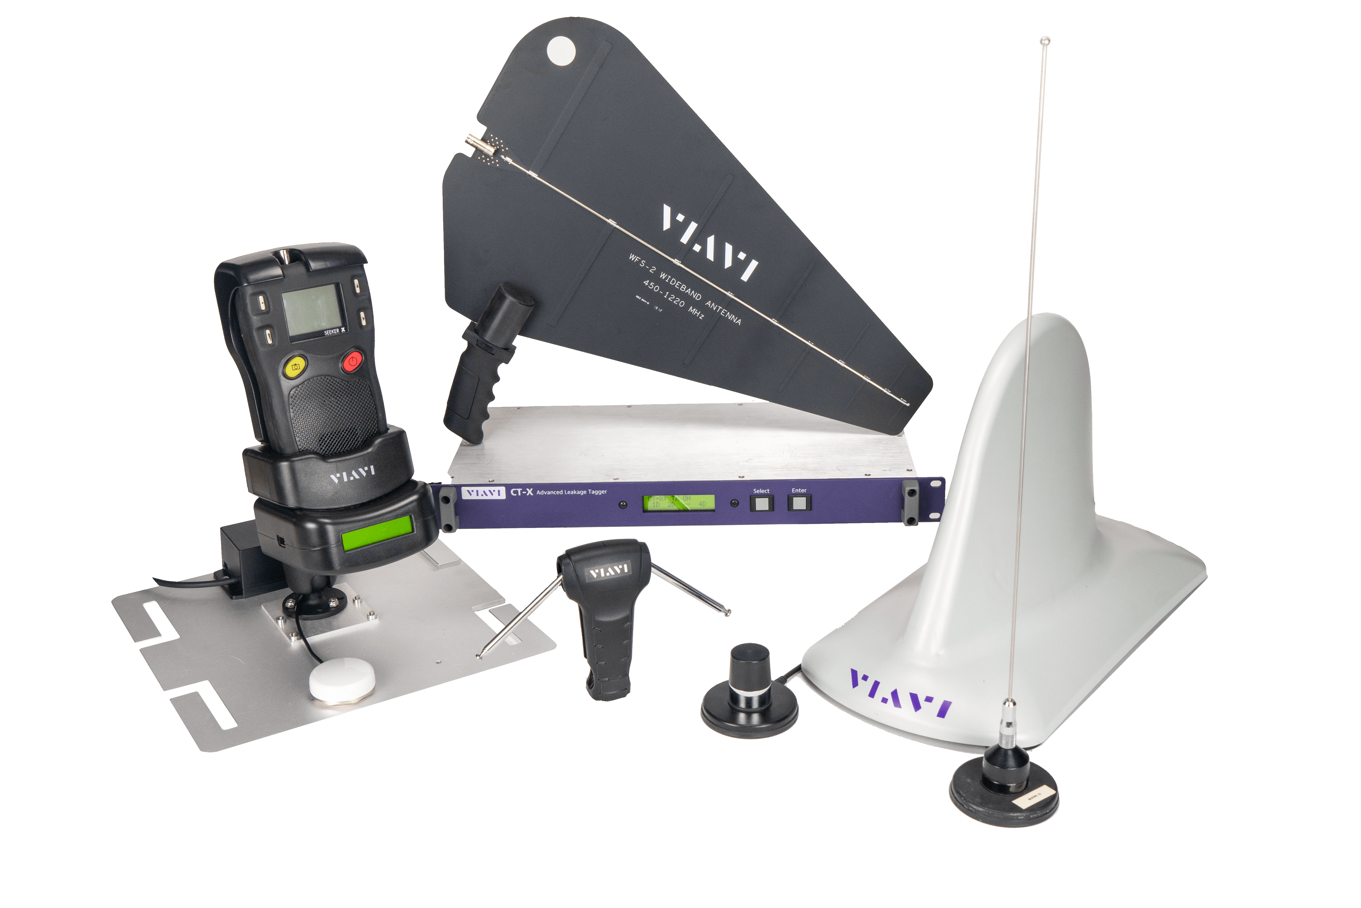
- Full-spectrum agility from 130-1220 MHz
- Up to 4 concurrent detection frequencies, including DOCSIS3.1/OFDM carrier support
- Virtualized tagger support for R-PHY/DAA nodes
- Supports new Seeker X digitally tagged carriers for increased leakage sensitivity and improved positive leak detection
- Mobile Tech app connected, StrataSync enabled, XPERTrak integrated
- Cost-effective solution backward compatible with existing VIAVI systems

specifications
Seeker X
Frequency Range | 130‒1220 MHz, adjustable via Seeker Setup Software and Mobile Tech App
Frequency Settings | 10 user-adjustable operating frequencies, selectable on front panel  Set using the configuration methods listed below
Receiver Sensitivity | -158 dBm
Calibrated Level Range | 1–2000 μV/m
Level Accuracy | ±2.0 dB
Display | Dual numerical readout of up to 2 detected leakage frequencies and carrier types within sensitivity range
Audible Tone | Tone is present if leakage amplitude exceeds squelch setting and digital tag is detected  Pitch is proportional to strength of leak
Automatic Noise and Overbuild Discrimination | Internal circuitry discriminates between leaks and noise  Overbuild discrimination provided by CT-X channel tagger installed in hub or head-end
Power | Internal battery with 3 hours of operation per charge; ~2 hours charging time  or  Vehicle power of 12 VDC while in Mobile Mount
Configuration Methods | - Mobile Tech App via Bluetooth  - USB connection from Leakage Detector to local PC running Seeker Setup Software  - Ethernet or WiFi connection from Seeker MCA III to the LAW Server while the Leakage Detector is located in the Mobile Mount

Seeker MCA III (Optional)
Standard Communications Interfaces | 10/100 RJ45 connection to fleet management systems  WiFi (802.11 a/b/g/n) to operator-controlled and configured hot-spot
Early Detection Notification (EDN) | Email notification of threshold exceeding leaks

ordering information
Package Name/Description | Package Part Number
Seeker-X Find and Fix kit w handheld antennas case and car charger | TRI-SKR-X-FIND-FIX-PKG
Seeker-X Mobile Find and Fix kit w/mobile mount vehicle/handheld antennas | TRI-SKR-X-DRIVE-PKG
Seeker-X Mobile Mapping kit w/MCAIII/GPS/MM vehicle antennas | TRI-SKR-X-DRIVE-ONLY-PKG
Seeker-X Mobile Mapping kit w/MCAIII/GPS/MM vehicle/handheld antennas | TRI-SKR-X-DRIVE-GPS-PKG

Description | Part # | Find/  Fix | Drive  Only | Drive/  Fix | Drive  GPS
Seeker X Mobile Mount | TRI-LKG-SKR-XVEH-MOUNT | - | ■ | ■ | ■
Seeker X Mobile Mount Wiring Kit | TRI-LKG-SKR-XMM-WIRE-KIT | - | ■ | ■ | ■
AC Travel Charger and USB Cable |  | ■ | - | ■ | ■
Wideband VHF/UHF Antennas
WFS-1 Low-band adjustable dipole  130 MHz – 450 MHz | TRI-LKG-ANTWFS-1 | ■ | - | ■ | ■
WFS-2 High-frequency wideband directional antenna 450 MHz – 1220 MHz | TRI-LKG-ANTWFS-2 | ■ | - | ■ | ■
WVM-2 magnetic base, wideband vehicle antenna (250–1220 MHz) | TRI-LKG-ANTWVM-2 | - | ■ | ■ | ■
UHF Band Antennas
AFS-7 Handheld YAGI antenna 580-640 MHz | TRI-LKG-ANT-AFS-7-YAGI | - | - | - | -
Rubber duck antenna, high band 580-690 MHz | TRI-LKG-ANTDUCK-HI | - | - | - | -
AVM-4 magnetic base, colinear array antenna  (612 MHz) | TRI-LKG-AVM-4 | - | - | - | -

description | Part # | Find/  Fix | Drive  Only | Drive/  Fix | Drive  GPS
VHF Band Antennas
AVM-3 magnetic base, vertical quarter wave whip antenna (trimmed to 130-150 MHz) | TRI-LKG AVM-3 | - | ■ | ■ | ■
Rubber duck antenna, low band 127-136 MHz | TRI-LKG-ANTDUCK-LOW | - | - | - | -
Near Field Probe
Near Field Probe | TRI-LKG-NFP-1 | ■ | - | ■ | ■
Optional Seeker MCA III
MCA III | TRI-LKG-SEEKERMCA-WIFI | - | ■ | - | ■
Seeker MCA III to Mobile Mount Power and Data Cable | TRI-LKG-SKR-MCAPWR-CBL | - | ■ | - | ■
2.4 and 5 GHz WiFi antenna | TRI-LKG-MCAIIIWIFI-ANT | - | ■ | - | ■
Shielded ethernet cable (10 ft) | TRI-ACCY-CAT5-10FT-QUAD | - | ■ | - | ■
Optional Accessories
GPS receiver for Seeker MCA II and Seeker  MCA III | TRI-LKG-GPS-MCA | - | ■ | - | ■
CL-9 vehicle power adapter | TRI-ACCY-USBPWRVEH-WCBL | ■ | - | - | -
Carrying bag with strap for meter and accessories | AC-BAG-METERMEDIUM | ■ | - | ■ | ■
Printed Quick Start Installation Checklist and Guide |  | ■ | - | ■ | ■
Digital Channel Tagger
CT-X Channel Tagger | TRI-LKG-CTX
Available Software
Seeker Setup Configuration Software | TRI-LKG-SW-SEEKER-PC
Hosted Leakage Analysis Software
(support for 5–1000+ instruments)

